**Program Loop dan Mirroring**

Christopher Ivan Gunardi – 18119025

Catatan: dalam program ini tidak digunakan “\” untuk memisahkan baris, namun program dapat dijalankan sesuai seharusnya.

**SOURCE CODE**

TOP_LEFT = "┏ "

TOP_CENTER = "┳ "

TOP_RIGHT = "┓"

HORIZONTAL_LINE = "━"

MIDDLE_LEFT = "┣ "

MIDDLE_CENTER = "╋ "

MIDDLE_RIGHT = "┫"

VERTICAL_LINE = "┃"

BOTTOM_LEFT = "┗ "

BOTTOM_CENTER = "┻ "

BOTTOM_RIGHT = "┛"

SYMBOL_1 = "▫"

SYMBOL_2 = " “

SYMBOL_3 = "▪"

LIMIT = 15 # membatasi bangun supaya tidak terlalu besar

MULTIPLIER = 2 # pengali sederhana untuk mengatur lebar bangun

def draw_top(size): # menggambar bagian atas

print(TOP_LEFT + HORIZONTAL_LINE*size*MULTIPLIER +

TOP_CENTER + HORIZONTAL_LINE*size*MULTIPLIER + TOP_RIGHT)

def draw_main(size): # menggambar bagian tengah

list1 = list(range(0, size + 1))

list2 = list(range(size - 1, -1, -1))

for line in (list1+list2):

if line == size:

print(MIDDLE_LEFT + HORIZONTAL_LINE*size*MULTIPLIER +

MIDDLE_CENTER + HORIZONTAL_LINE*size*MULTIPLIER + MIDDLE_RIGHT)

else:

print(VERTICAL_LINE + SYMBOL_1*((size-line)*MULTIPLIER-1) + SYMBOL_3 +

SYMBOL_2*line*MULTIPLIER + VERTICAL_LINE +

SYMBOL_2*((size-line)*MULTIPLIER-1) + SYMBOL_3 +

SYMBOL_1*(line*MULTIPLIER) + VERTICAL_LINE)

def draw_bottom(size): # menggambar bagian bawah

print(BOTTOM_LEFT + HORIZONTAL_LINE*size*MULTIPLIER +

BOTTOM_CENTER + HORIZONTAL_LINE*size*MULTIPLIER + BOTTOM_RIGHT)

def draw_shape(size): # menggambar bangun

draw_top(size)

draw_main(size)

draw_bottom(size)

def input_size(): # melakukan input

size = int(input("Input a positive integer: "))

if (size < 1):

return 1

elif (size > LIMIT):

return LIMIT

else:

return size

size = input_size()

draw_shape(size)

**HASIL**

Bangun simetri atas bawah

Input = 0

Input dinaikkan menjadi 1

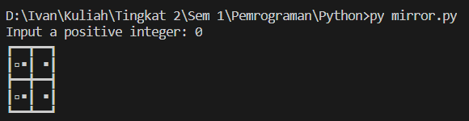

Input = 100

Input diturunkan menjadi 15 (LIMIT)

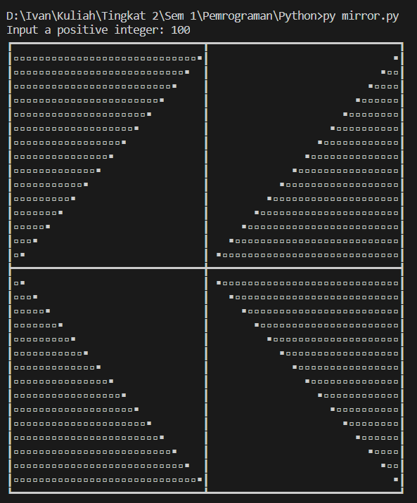

Input = 10

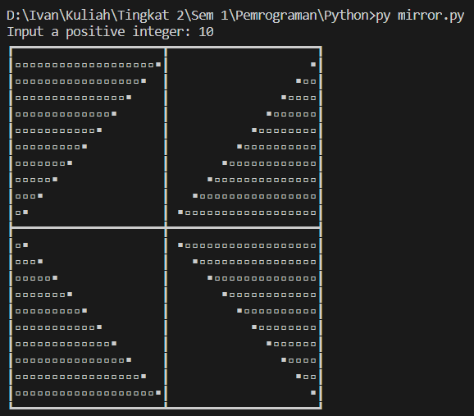

Input = 4

